IHE Change Proposal

Tracking information:
IHE Domain | PCC
Change Proposal ID: | CP-PCC-205
Change Proposal Status: | Incoming
Date of last update: | 2014.12.23
Person assigned: | (assigned by Domain Technical Committee)

Change Proposal Summary information:
OID for NEMSIS Coding System Wrong in CDA Supplement
Submitter’s Name(s) and e-mail address(es): | Steve Moore
Submission Date: | 2014.12.22
Integration Profile(s) affected: | ETS
Actor(s) affected: | Content Creator, Content Consumer
IHE Technical Framework or Supplement modified: | Rev 2.4, 2014.12.03
Volume(s) and Section(s) affected: | Volume 3, Sections 6.4.4.6.22, 6.3.3.7.8, 6.3.3.7.11
Rationale for Change:
Three examples below where the Code chosen for a section is not a LOINC code.
- The examples still use the OID for LOINC while the codeSystemName is NEMSIS
- The table template that we use says “LOINC Code”. We need a little tweak if indeed you want to use NEMSIS.
- For the section in 6.3.3.7.8, Mass Casualty Incident Section, the LOINC Code in the stylized table is “NA – NEMSIS EScene 0.7”. The example does not have the “NA – “ prefix. This is confusing. The other two sections do not have this “NA – “ prefix in the sylized table.

- The Table says LOINC Code
- The example uses the OID for LOINC
- The codeSystemName in the example is NEMSIS. This codeSystemName does not match the first two items.

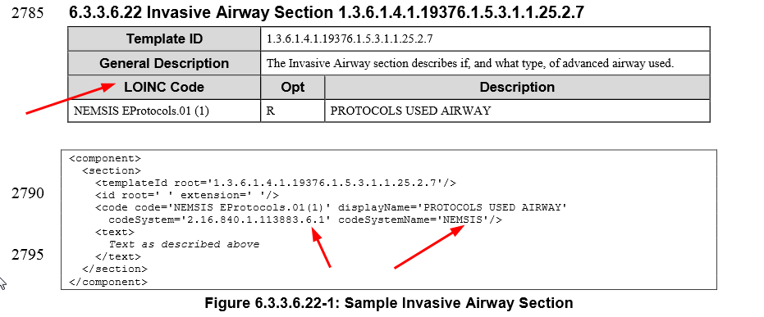

- The Table says LOINC Code
- The example uses the OID for LOINC
- The codeSystemName in the example is NEMSIS. This codeSystemName does not match the first two items.
- Is the coded value “NA – NEMSIS Escene 0.7” or is the “NA – “ a prefix to indicate this is not LOINC. It is confusing, especially because it is not done this away for the other two sections that use NEMSIS.

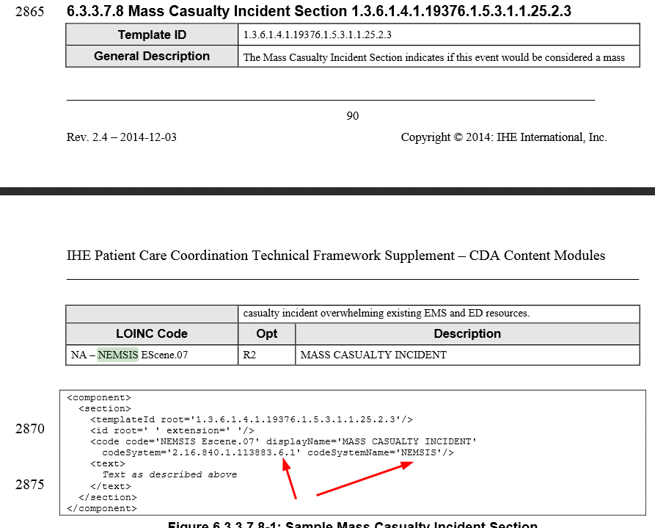

Rationale for Change:

- The Table says LOINC Code
- The example uses the OID for LOINC
- The codeSystemName in the example is NEMSIS. This codeSystemName does not match the first two items.

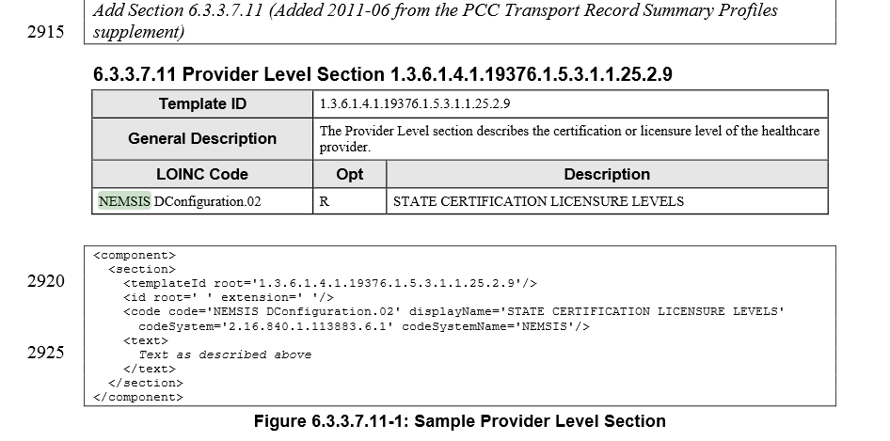

Replace Section X.X by the following:
or
Add the following section after Section X.X:

